SVDP BREAD FOR LIFE COMMUNITY FOOD PANTRY

219 East Muir Avenue
Bardstown, Kentucky 40004
502-348-7270 bflmanager@svdpbard.org

FOOD DRIVE RESOURCE PACKET
2018

`

St. Vincent de Paul of Bardstown

THANKS FOR EXPRESSING AN INTEREST IN HOSTING A FOOD DRIVE!
Whether you have hosted food drives year after year or this is your first time, this packet will help you organize a successful drive and give you ideas on how to increase awareness of hunger in our community.

PEOPLE ARE COMPASSIONATE, THEY WANT TO HELP
Often they simply do not know what the need is or how to best help. Your food drive can educate our community about food insecurity and the best ways to address it.
“I am only one, but I am one. I cannot do everything, but I can do something. And because I cannot do everything, I will not refuse to do the something that I can do.”
~Edward Everett Hale

THE FACTS:
Every day, people in Nelson County go hungry. As of 2018, the poverty rate in Nelson County is 12% - about 2,100 households live below the federal poverty line. At Bread for Life Community Food Pantry, we serve some 600 different families each month. They represent every zip code in Nelson County. The average household income is $900 per month; our average client household spends 55% of their income on housing. 76% of our households are headed by someone who is elderly or permanently disabled. Each month, our pantry distributes over 50,000 pounds of food – 25 tons!

Where Do I Start?
1.Get approval from the leadership or management of your organization. To make it a success, you will also need to follow organizational rules about workplace giving and soliciting of items.
2. Select a food drive committee. Food drives are fun. But they also require a certain amount of planning in order to be successful. Gather a small group of individuals who want to be an integral part of your drive and assign everyone specific tasks.
3.Try including a fund drive as part of your food drive. Some people will find it more convenient to offer a monetary donation instead of food. In addition, your company may choose to provide a donation matching the amount items collected from the employees. The employee’s donation plus the “matching funds” of the company provides greater support to the hungry. While we appreciate the variety of food received from a food drive, monetary donations allow us to purchase food from our local food bank, Feeding America, at a greatly reduced price. $1.00 will provide over 6 pounds of food.
4. Set your goals. Determine the amount of food you want to raise. You may want to think in terms of raising so many pounds of food per employee or student or member in your organization. If you held an event previously, advertise your past success and set a goal to better the food and/or fund total.

5. Pick your dates. Select your dates for the food drive (the average drive is 2 weeks to 4 weeks but could be for a one day drive or just at an event.)
6.Announce your drive and goal. Make sure you tell everyone the start and finish date of the drive and what foods you want to collect.
…This is your chance to educate people about hunger in our community and how your group can help end hunger.
…You might want to schedule a kickoff to create interest in the food drive and offer a special treat at the kickoff to everyone who brings a food item or makes a monetary donation to start the drive.
…Advance publicity can make the drive more fun and raise enthusiasm.
7. Register your food drive. Complete and send in the registration form at the back of this packet or call or email the Food Pantry Manager about your food drive.
8. Set-up collection points. Place your signs, posters, and collection boxes in high traffic areas. Places such as the lobby and lunchrooms work well. If you have competitions between groups, place the boxes in their areas. Make sure you have an adequate supply of boxes, not too large that it will make it harder to carry them when filled with donations, and a place to hold and store food until the drive is over.
9.Deliver or arrange delivery of the food and funds to Bread for Life Community Food Pantry. You can deliver donations to the pantry anytime it is open. For large food drives, we can make arrangements to pick up your donations. Just call us at 502-348-7270. If you would like to promote the charitable efforts of your company or organization through internal and/or external media, make sure to let us know. We can help with large logo display signs or oversized checks (for monetary donations).
10. Announce your results and celebrate success! Bread for Life Community Food Pantry will send an acknowledgement/thank you letter for your donation of food and/or funds. We will also gladly submit photographs to the Kentucky Standard, Facebook, etc. for potential publication if requested.

Look how far your dollar goes!

Creative Ideas
Ways to Increase Donations
… Ask each department or school grade to bring in a particular item (i.e., one group brings in cereal, another group brings in tuna, a third group brings in soup, etc.).
… Have theme days such as Macaroni Monday, Tuna Tuesday, Whatever Wednesday, Think of Others Thursday, Fruity Fridays, PJ Day – everyone donates peanut butter so they can wear pajamas to school.
… Jeans for Beans. If you have a business dress code, allow employees to wear casual or dress down if they bring in a bag or can of beans.
… Charge canned food for admission to special events such as concerts, luncheons, trainings, ice cream socials or other fun events.
… Create teams and have a contest to see who collects the most food or monetary donations.
It could be measured by weight or by the number of items.

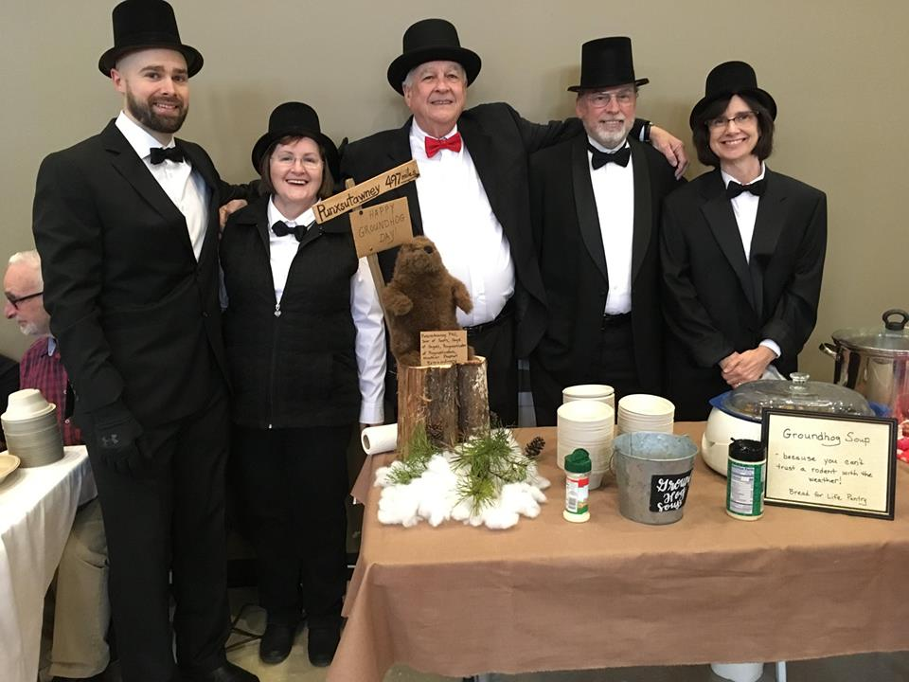
FUN IDEAS
For Your Food Drive
…Create a Board and Thermometer to display your progress for both food and monetary donations.
…Host a Competition between grades, classrooms, company departments, etc.
… Stuff a Bus or Pack the Pickup. You can also have a contest to guess how much food is in the vehicle.
…Build a Sculpture of the cans or spell out your company or school name with the food.
…Decorate the Barrel or Box and/or where the barrel is stationed with a celebration theme.
…Connect your Drive with spirit week, homecoming or another special week at school to tie in the theme of giving.
…Have Students or Employees Bring In their favorite type of food and leave it on their desk or workstation for the day before collecting it to generate conversation about the drive.
… Create A Sports Theme: Tackle Hunger , Hit a Home Run Against Hunger, Knock Out Hunger.
… Skip Lunch, Feed a Bunch: employees can donate the money they would have spent on a lunch.

If you can’t feed a hundred people, then just feed one.
~Mother Teresa

MOST NEEDED ITEMS
Canned meats, fish (tuna, chicken, salmon)
Fruit (canned, cups, dried)
Vegetables (canned)
Cooking Oil
Baking Mixes
Boxed Meals (tuna helper, stuffing, hamburger helper, mac & cheese, etc.)
Coffee/Dry Creamers
Condiments (ketchup, mustard, mayo, BBQ sauce, etc.)
Breakfast Cereals/Oatmeal
Pasta/Spaghetti Sauce
Baby Essentials (formula, snacks, baby food ,etc.)
FOOD DRIVE
Registration Form

BREAD FOR LIFE FOOD PANTRY Bardstown, Nelson County Kentucky

Company/Organization/School: __________________________
Number of Employees/Students/Members: ___________________
Contact Person: ______________________________________
Phone: ____________________________________________
Email:_____________________________________________
Address:___________________________________________
Mailing Address: (if different from above)_____________________ __________________________
_________________________________________________
Anticipated Dates for Food/Fund Drive ______________________ ______________________
Do you hope to add a monetary component to your drive?__________
Do you anticipate needing your donations to be picked up? ____

Please mail or email this completed form to:

Chris Godbey, Manager
Bread for Life Community Food Pantry
219 E. Muir Ave.
Bardstown KY 40004
bflmanager@svdpbard.org

Courtesy of the Kentucky Standard;
Photo by Randy Patrick

Frequently Asked Questions
Do you have containers to collect food we can use?
Yes. We have a limited number of large plastic barrels with logos that you can use. Also, we usually have boxes available that work well for food drives. Just call us to make arrangements.

Can you pick up the food we collect?
Yes. We have both a covered pick-up truck and a large box truck that we can use to pick up your donation. If you have a large donation, it is very helpful to have volunteers from your organization to help load our truck. It is also a great photo opportunity for your organization.

Are we supposed to weigh the food we are donating?
You certainly can if you want; however, we keep track of the weight of all food that we distribute. We have a large industrial scale at the pantry that makes it easy to weigh. You are welcome to join us in weighing your food donation at the pantry. Many children (and adults) enjoy this part of the delivery and seeing how much food they have collected.

Do you prefer monetary donations to food donations?
We like both! Food drives serve as an opportunity to educate our community about their neighbors who struggle to put food on the table. It provides a concrete example of how someone can help – especially for children. On the other hand, the need in Nelson County simply cannot be met by food drives alone. Through Feeding America and other very low cost food providers, we are able to dramatically increase (often ten-fold) the amount of food we can distribute. Ideally, food and fund drives are done together. Please, however, do not use money collected to purchase food to include in your drive. We have access to much, much lower pricing. We are very glad to add to your total food drive the amount we will be able to purchase with your monetary donation.
Are there special guidelines about the food that I should know?
We can accept and distribute food that is past its “best if used by date”, however, we do not distribute “expired” food. We do not distribute food that has been opened or home canning products. We do take baby food and pet food and non-food items such as paper towels, toothpaste, and diapers (all must be in new, unopened wrappers and packages).

Are there volunteer opportunities at the food pantry?
YES. If you are interested in volunteering, please email the pantry manager bflmanager@svdpbard.org
or call 502-348-7270

How do I find out how much we collected?
We will send you an official thank you letter shortly after the drive. If your drive is during the holidays, the letter may take a few weeks because of the volume. If you would like to know the weight before your letter arrives, please call or email.

Volunteers in Action

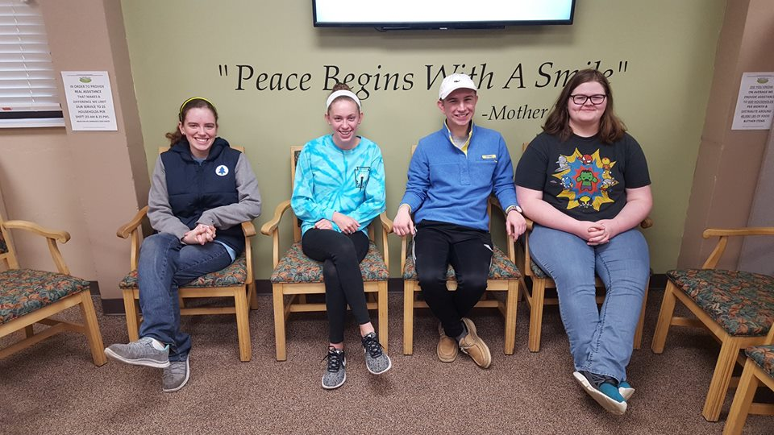
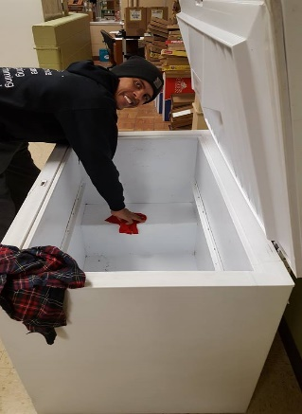

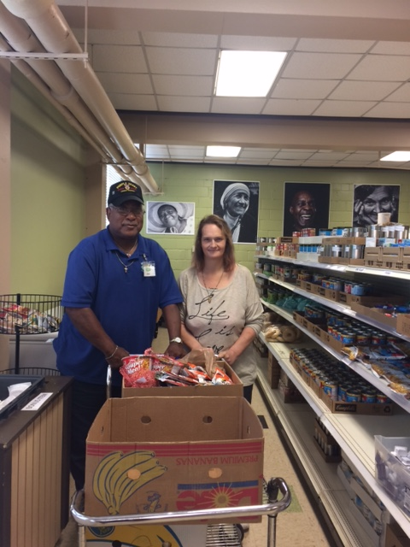

Sample Letter to Participants

Dear _______________________________ (participant)
Our organization is holding a food drive on (Dates) to benefit the Bread for Life Community Food Pantry, a local non-profit serving families and individuals in Nelson County. This is a great opportunity to help feed the hungry in Nelson County and everyone is encouraged to join in the effort.
All food and funds raised will be used to help Bread for Life distribute food to those in need here in Nelson County. Bread for Life Community Food Pantry is working hard to serve our community and help the large number of families who are food insecure. Food insecure families are so limited in their resources to buy food that they are running out of food significantly reducing the quality of their food, or foregoing medicine or rent or other basic expenses to pay for food.
Here are some startling statistics about hunger in Nelson County:
Poverty and hunger exist in Nelson County. Even though the economy may be doing very well, we still face a poverty rate of 12% in Nelson County. This means, based on U.S. census figures, that more than 2100 households in Nelson County are living in poverty, more than 30% of whom are children.
The Bread for Life Community Food Pantry helps more than 600 different households each month. The families come from every zip code area in Nelson County. More than 75% of the families are headed by someone who is elderly or permanently disabled. The average pantry household is $900 per month. On average, those living in poverty spend more than 55% of their income on housing.
The goal of Bread for Life Community Food Pantry is to provide free food to those in need, while working to eliminate hunger and food insecurity in Nelson County.
HERE’S HOW YOU CAN HELP
Donate non-perishable foods in the marked containers at collection points in our location during the drive.
Donate money. For every dollar donated, Bread for Life can purchase 6 pounds of food to distribute to a hungry person. That is almost 5 meals!

Thank you for your help!
-----------------------------
(Food Drive Coordinator, Organization Leader, or Company Executive’s Name)
COME VISIT US AT
219 East Muir Avenue
Bardstown, Kentucky

Bread for Life Community Food Pantry is a ministry of
St. Vincent de Paul Outreach Ministries under St. Joseph Proto-cathedral, Bardstown

St. Vincent de Paul Ministries of Bardstown

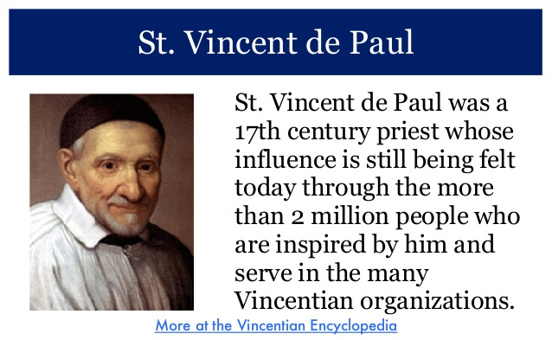
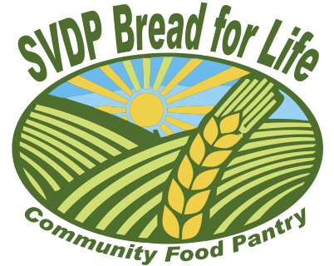
www.svdpbard.org
MEALS FROM THE HEART

Giving help, support, and hope to people in need.

